**Characters:**

**Rage**

A small ball of anger that gets heated very quickly. It finds itself completely alone at the start of the game and can thus be considered the main character. Loses itself in anger once its ability is activated, causing it to dash forward in blind

rage. Furthermore, its flames start burning even stronger. These effects can be used to break through certain walls, set of explosives, light flammable objects and push movable objects.

**Ability - Rampage**

Makes Rage dash forward and his flames burn stronger. This ability can be used to destroy breakable walls, light flammable objects, push certain stones and activate explosive objects.



**Depression**

An accumulated mass of sadness that cries whenever it gets the chance. After being seperated from the other emotions, it simply started crying until Rage eventually meets up with it. Starts to cry uncontrollably when its ability is activated, which can be used as a jetpack to reach high areas.



**Ability - Crybaby**

Makes Depression cry a huge amount of tears in one stream. This can be used to propel it up onto high platforms otherwise unreachable.



**Anxiety**

An easily frightened concoction of all kinds of fears. It froze up

once it realized that it was all alone until the others join it.

It freezes in place once its ability is activated, causing it to

become invulnerable and making projectiles repel from it.



**Ability - Cold Feet**

Makes Anxiety freeze in place. This can be used to repel enemy attacks and as a platform for the other characters.

**Stress**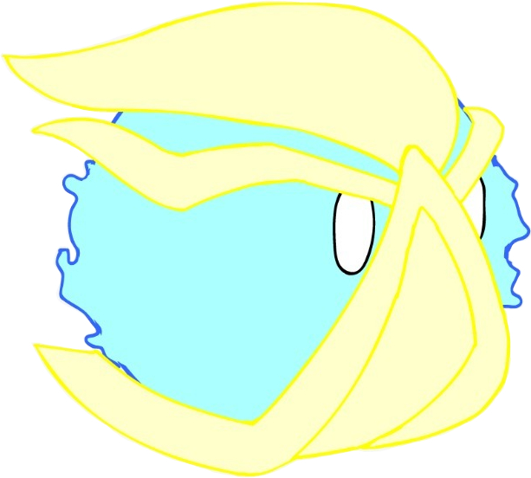

A combination of Rage and Anxiety which doesn't listen to any kind of reason. Will always charge forward without any concern for its surroundings, even putting itself in danger to reach its goal.

**Ability - Frozen Outrage**

Stress runs very fast and becomes invulnerable for a few seconds.

This can be used to run over hazardous terrain.

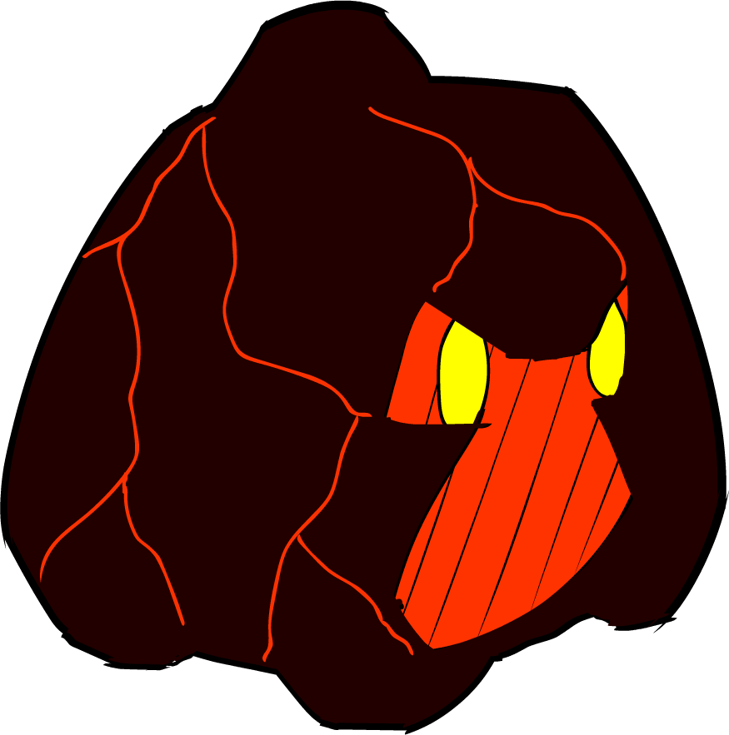

**Frustration**

A combination of Rage and Depression that has been lost to despair. It finds no other way to express its feelings other than bringing all of its stored up feelings out in a stream of hot lava.

**Ability - Eruption**

Frustration cries magma tears that harden immediately. This can be

used to create new paths.

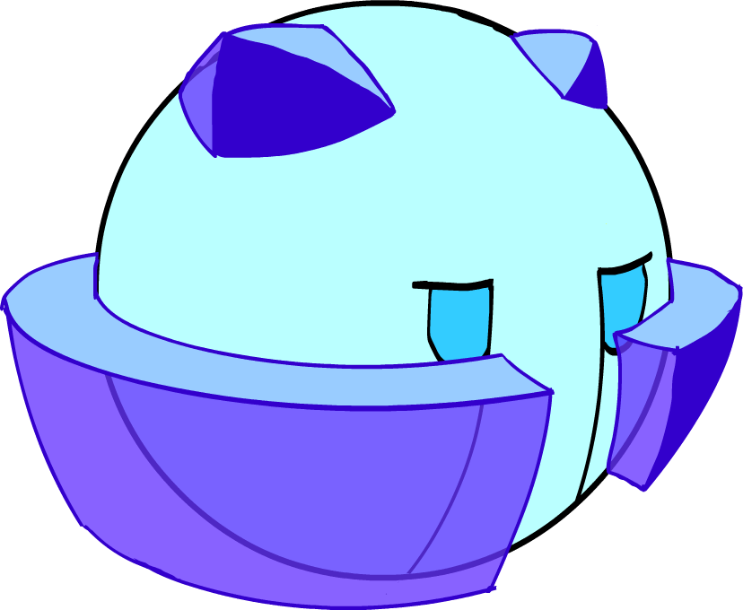

**Apathy**

A combination of Depression and Anxiety that has shut

itself of from its surroundings. It seems no reason to do

anything anymore and has even lost its ability to cry normal

tears

**Ability - Icey Tears**

Apathy can shoot controllable frozen tears. This can be used

To activate unreachable mechanisms

**Objects:**

**(Breakable) Walls/Pillars/Platforms**

The cave that the emotions find themselves in after being seperated from the other emotions is constructed mostly out of these elements. They are all naturally formed, although time certainly has taken its toll on some of the walls.

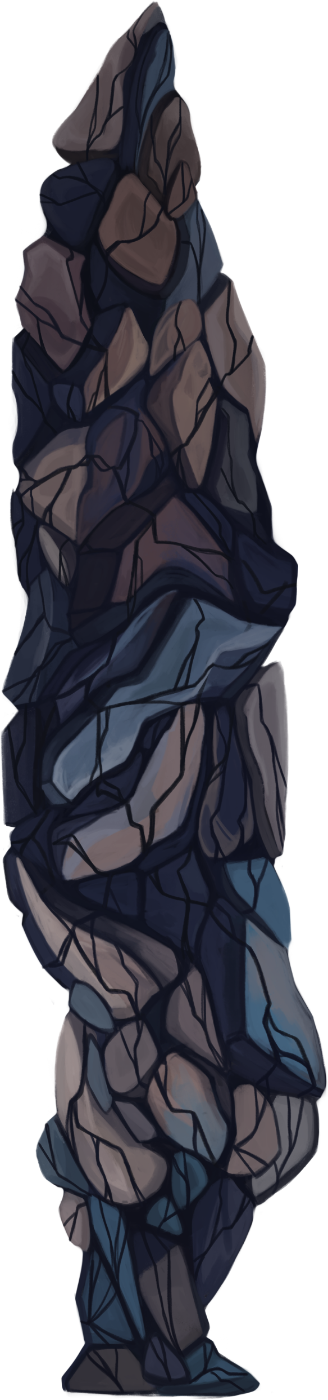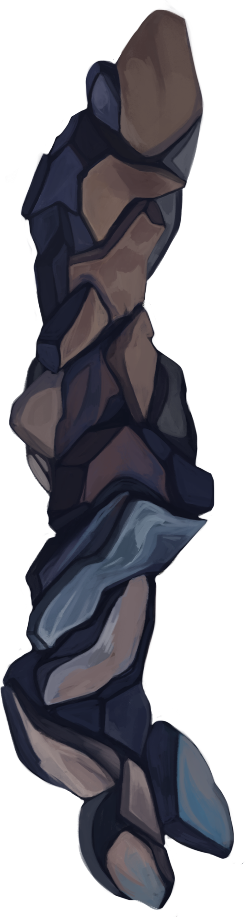

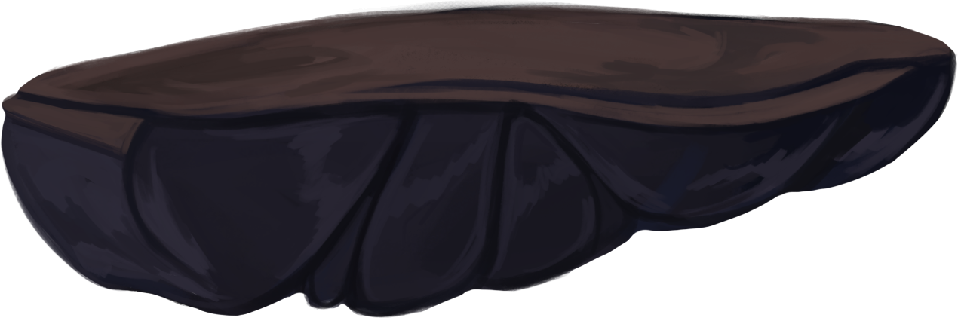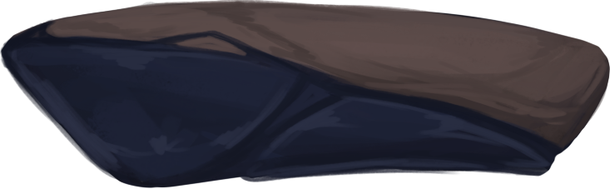

**Movable Stone/Boulder**

Loose rock formations that have been severed from the ground. While still very heavy, they can be pushed by applying a big amount of force on them

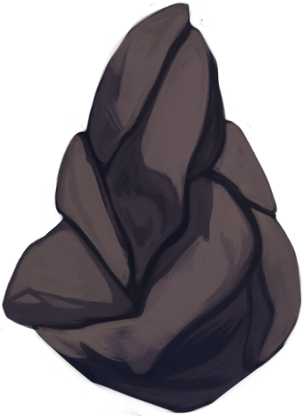

**Switch**

These eyes are placed all over the cave. Though the specific mechanisms are unknown, they somehow control all functions and are a key part in progressing.

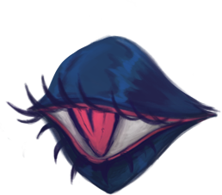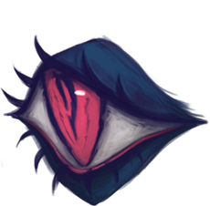

**Elevator Platform**

A mysterious kind of platform that seems to somehow be controlled by the eyes in the cave. Can change its altitude and transport the characters to new areas of the cave.

**Fire Flowers**

Natural vegetation that found a perfect habitat inside the cave. Evolved into various kinds based on its area of growth, but always uses some variation of fire to protect itself from foes.

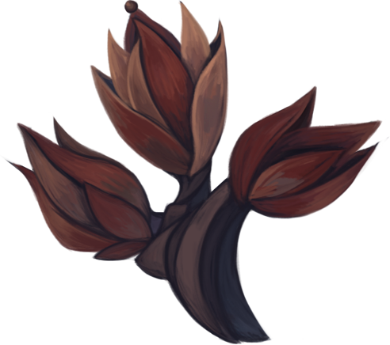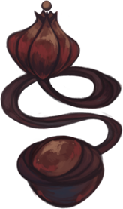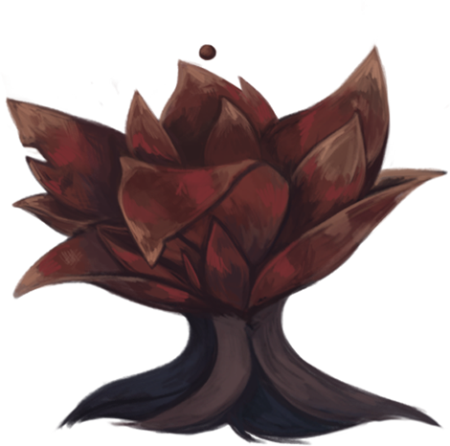

**Explosive Mushrooms**

Mushrooms that can only grow inside this cave due to its high humidity. Highly explosive due to the tiny size of its spores that react similarly to heat as dust.

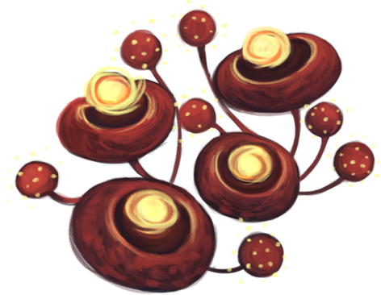

**Exit**

Entrance to corridors that connect the multiple parts of the cave. This is the main goal the characters are aiming for within each section.

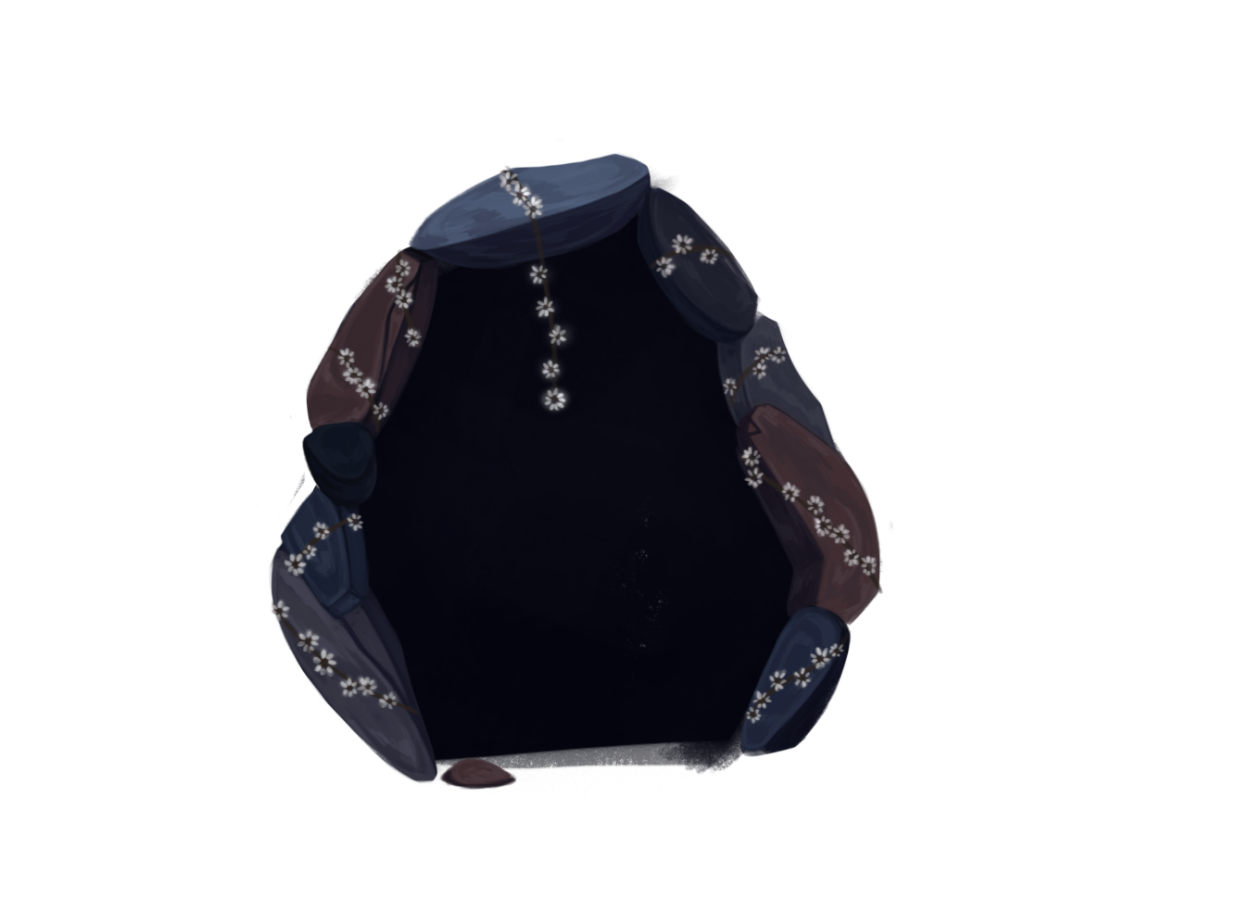

**Hazards:**

**Duskfeather**

Mysterious, dark, raven-like beings that guard the cave. Although they can't move, their projectiles are dangerous enough to pose a threat to any intruders or escapees.

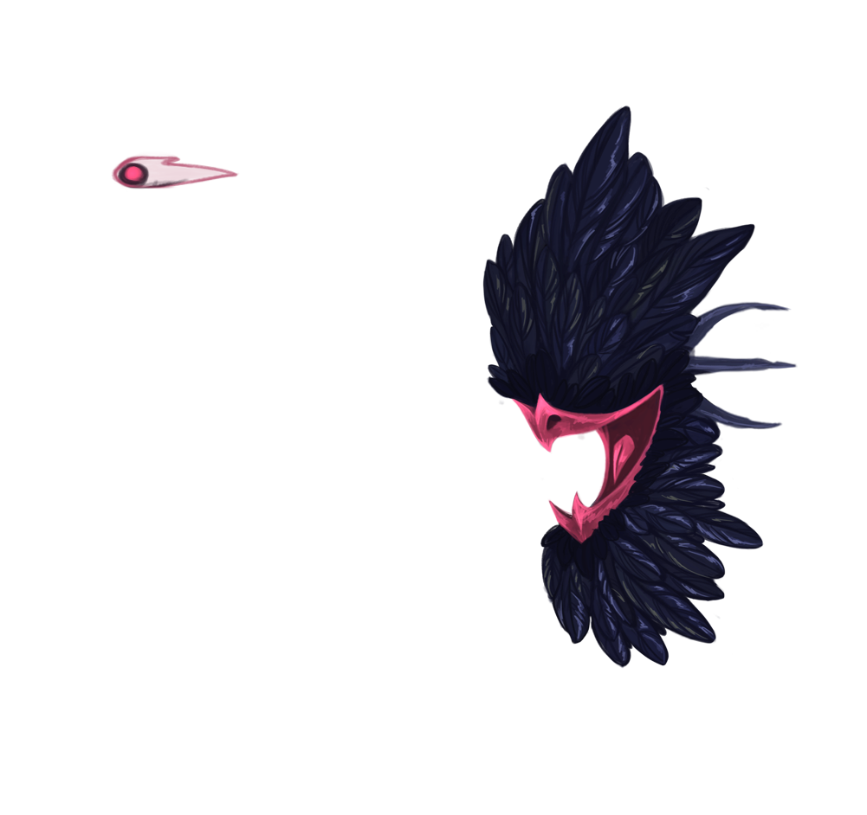



**Spikes**

Naturally formed rock protrusions that are sharp enough to pierce on contact. Avoid at all costs!

